**Client-Side App Rubric** <https://github.com/denisecase/pbl-lifeline-links>

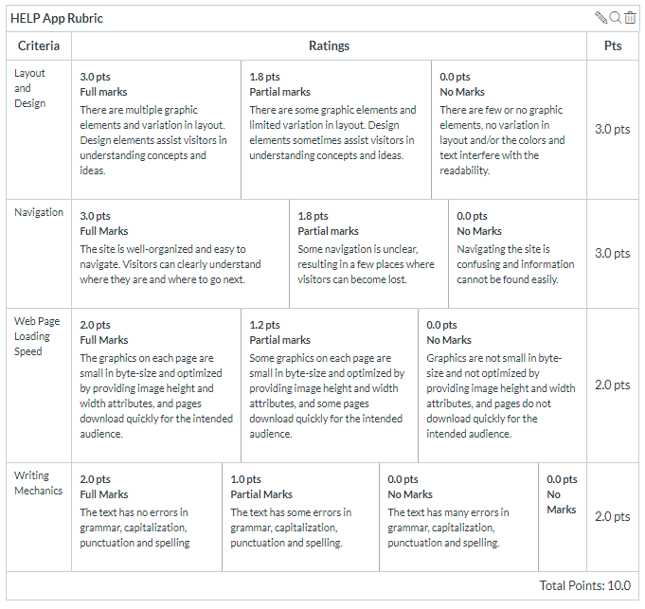

**Team reviewed: Group 01-02**

**Link to the web site:** <https://rethima-reddy.github.io/Help-app/>

**Layout and Design**

Score: 2.5

Comments: The overall layout is pretty decent, the look of the side is big enough that the average user would be able to read the site and be able to understand what they are looking at because of the separation between texts. With that said, the colors of the header mismatching the colors used in the rest of the site that can be visually displeasing.

**Navigation**

Score: 1

Comments: The navigation is something that will require work due to home and about going to the same page, as well as after you get to history, the entire navigation changes from “Home, about products, pricing, history, contact us” to “Index, History, Highlights, contact us”. It’s probably just an error on the part of the nav not being the same on every page, however, if kept the same, it can cause for issues. As well as after History the nav loads on separate pages. If you are wanting to have it load on the same page like most of the site, consistency would be key throughout.

**Loading Speed:**

Score:2

Comments: Loading speed it loaded fine, there weren’t anything that took to long to load when navigating the site or initially opening the site.

**Writing Mechanics:**

Score: 2

Comments: After looking through, could not find any grammatical issues.

**General remarks:**

Overall, the site has a lot of text in some locations (ie history), however the home page gets the point across on everything the site is wanting. It has the product, what the product is, etc. The nav being completely a different color can throw off some users due to nothing being the same color throughout the site.

**Review performed by:**

**Ricky Calderon**

**Aaron Stahl**

**Date and time performed:**

**12/5/2019 12:55**